Planar 3R FTW optimal configuration:(considering Area,Connectivity only ):
L1+l2+l3=3
Li from 0-1
A[0]=(-a,a)
Objective function: Area*Connectivity
Name | L | A in degree | Area | Connectivity | A*C | Angle sections | Kernel size
Generic algorithm optimal value | [0.4888656043245976, 1.3992499610293656, 1.1118844346460368] | [(-3.1315926535897933, 3.1315926535897933), (-0.9272951769138392, 2.2142957313467018), (1.8545903538276785, 1.8545903538276785)] | 64513 | 0.8788047497034407 | 56694.33081761807 | 20 | 4
Optimal value considering only area in paper | [0.5,1.25,1.25] | [(-180,180), (-53.1301, 126.8698), (106.2602, 106.2602)] | 64872 | 0.8554260165435227 | 55493.1965452114 | 20 | 4
Optimal value local searched | [0.5,1.25,1.25] | [(3.1215926535897935, -3.1215926535897935), (-0.9272951769138392, 2.514295731346702), (1.8545903538276785, 1.8545903538276785)] | 64853 | 0.8631103060742767 | 55975.29267983507 | 20 | 4


GA paper

Planar 3R FTW optimal configuration:(considering Connectivity only ):
L1+l2+l3=3
Li from 0-1
A[0]=(-a,a)

Name | L | A in degree | Area | Connectivity | Angle sections | Kernel size
Generic algorithm co-optimal value 1 | [1.0623688707624126, 1.3949665883050613, 0.5426645409325261] | [(-29.8573,29.8573), (141.6532, 160.7817), (163.1636, 171.3037)] | 637 | 1->  0.8778927083391218 | 50 | 4->2
Generic algorithm co-optimal value 2 | [1.3790446119033932, 1.2470558000667031, 0.37389958802990364] | [(-60.9519,60.9519), (149.8883, 151.0295), (-170.7127, 114.2115)] | 445 | 1->0.96 | 50 | 4->2

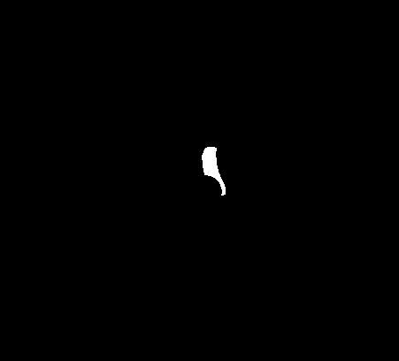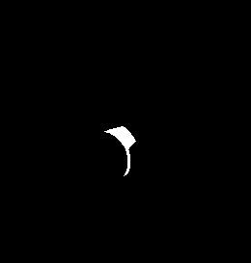

Issue: kernel size too small will cause erosion and dilation of large workspace not converge.
kernel size too large will misinterpret connectivity of small workspace.
kernel size need to be the same for all configuration when doing optimization.

Conclusion: avoid only optimizing connectivity.

- Test different reliability prob for a reasonable setting which output’s ftw is not empty
- Test weighted product of Area and connectivity, A^a*C*b
Planar 3R FTW optimal configuration:(sigma R*A*C)
L1=0.5，L2=1.25，L3=1.25
A[0]=(-a,a)
R1=0.5,r2=0.6,r3=0.7

Name | L | A in degree | Sum(C*A*R) | Angle sections | Kernel size
Generic algorithm optimal value | [0.5,1.25,1.25] | [(-3.1215926535897935, 3.1215926535897935), (-0.9272951769138392, 1.9711104241671151), (1.821405046648092, 1.8545903538276785)] | 225442.25824300566 | 20 | 4
R1 | R2 | R3 | R1r2 | R1r3 | R2r3 | FTW
55525.61 | 58035.82 | 57347.33 | 55525.61 | 56248.78 | 57347.33 | 56248.78
Only consider Area(from paper)
55571.25 | 56152.23 | 56048.80 | 55571.25 | 55493.20 | 56048.80 | 55493.20

GA:J1J2J3Ftw Paper: J1J2J3Ftw

Planar 3R FTW optimal configuration:(sigma R*A*C)
L1=L2=L3=1
A[0]=(-a,a)
R1=0.5,r2=0.6,r3=0.7

Name | L | A in degree | Sum(C*A*R) | Angle sections | Kernel size
Generic algorithm optimal value | [1,1,1] | [(-3.031883452592004, 3.031883452592004), (-1.619994146091692, -0.8276157453255935), (-1.6977602095460234, -0.7265946655975718)] | 118927.02367072657 | 20 | 4
R1 | R2 | R3 | R1r2 | R1r3 | R2r3 | FTW
10371.98 | 87681.28 | 84563.15 | 10271.60 | 9755.58 | 84563.15 | 9755.58
Paper | [1,1,1] | −18.2074◦, 18.2074◦, −111.3415◦,  111.3415◦, -111.3415◦, 111.3415◦ | 48471.42926075609 | 20 | 4
40958.17266153355 | 8684.619744586009 | 8660.762919190141 | 8036.939966858477 | 8017.834739728416 | 8650.093260415866 | 8007.037110515549
J1J2: J1J3


J2J3 ftw

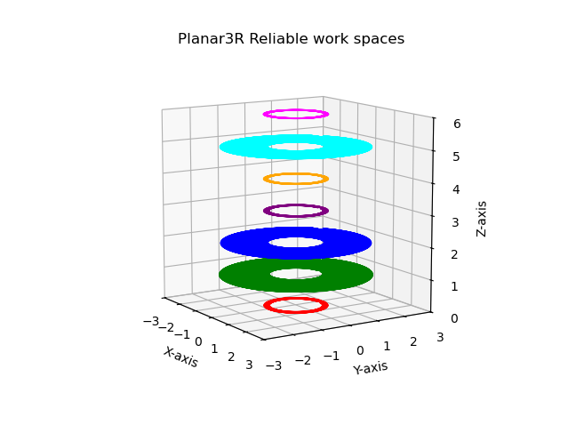

Paper:
J1J2: J1J3:



J2J3: ftw:


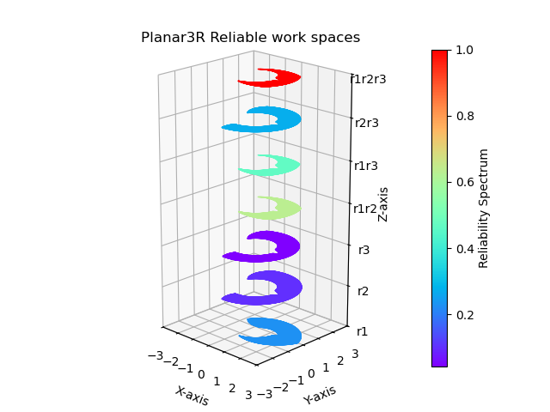
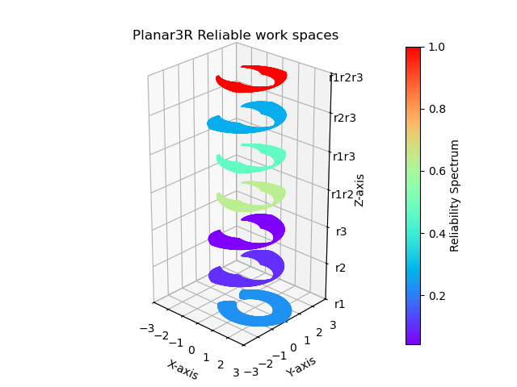

Planar 3R FTW optimal configuration:( A*C)
L1=L2=L3=1
A[0]=(-a,a)

Name | L | A | Area | Connectivity | Angle sections | Kernel size | A*C
Generic algorithm optimal value | [1,1,1] | [(-0.7391244590957556, 0.7391244590957556), (-0.7422740927125862, 1.9756037937159996), (-2.11211741668124, 2.12020510030)] | 21768 | 0.8854245441374203 | 20 | 4 | 19273.921476783366
Only consider Area(from paper) | [1,1,1] | −18.2074◦, 18.2074◦, −111.3415◦,  111.3415◦, −111.3415◦, 111.3415◦ | 28579 | 0.28017205327392664 | 20 | 4 | 8007.037110515549
GA:
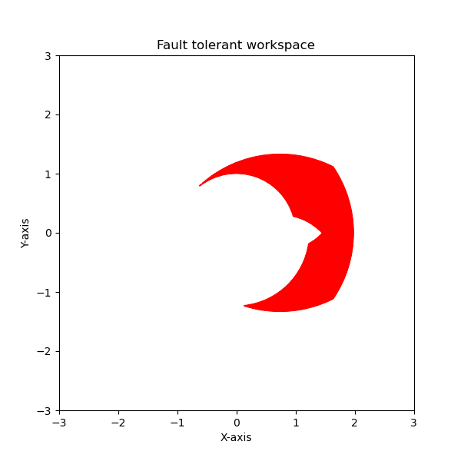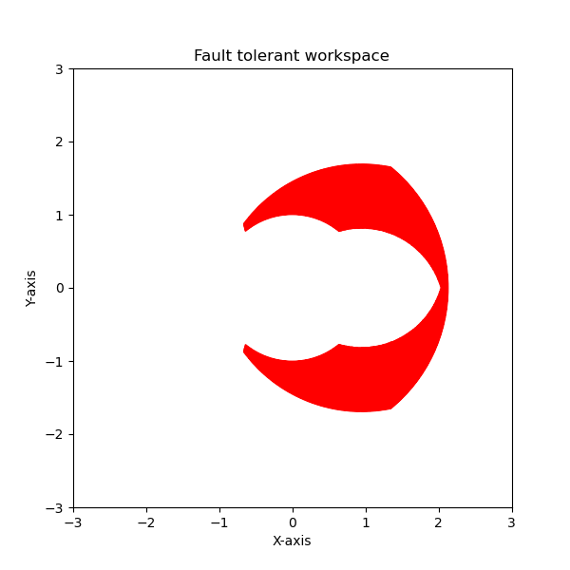

Paper

Planar 3R FTW optimal configuration:( A*C)
L1=2^0.5
L2=2^0.5
L3=(2/3)^0.5
A[0]=(-a,a)

Name | L | A | Area | Connectivity | Angle sections | Kernel size | A*C
Generic algorithm optimal value | [sqrt(0.5),sqrt(0.5), sqrt(2/3) | [(-0.5779611440942315, 0.5779611440942315), (-1.1887031063410372, 0.6453736884533061), (-1.7852473794934884, 1.8681718728028136)] | 13236 | 0.9524525447234751 | 20 | 4 | 12606.661881959915
Generic algorithm optimal value ａｏｎｌｙ ａｒｅａ | [sqrt(0.5),sqrt(0.5), sqrt(2/3) | (-0.07796114409423144, 0.07796114409423144), (-1.4718884135206238, 1.5453736884533062), (-1.7852473794934884, 1.8681718728028136) | 20844 | 0.19134854663976494 | ２０ | ４ | 3988.4691061592603

ＡＣ Ａ
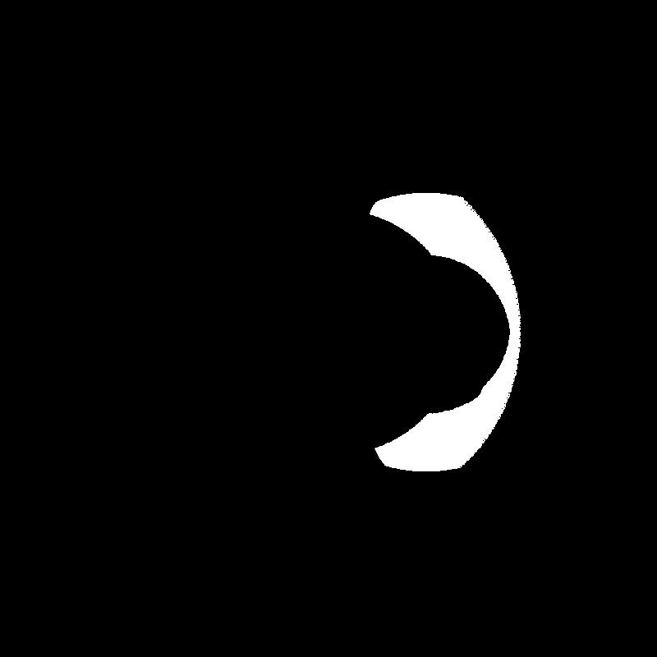

Planar 3R FTW optimal configuration:(sigma R*A*C)
L1=2^0.5
L2=2^0.5
L3=(2/3)^0.5
A[0]=(-a,a)
R1=0.5,r2=0.6,r3=0.7

Name | L | A in degree | Sum(C*A*R) | Angle sections | Kernel size
Generic algorithm optimal value | [1.4142135623730951, 1.4142135623730951, 0.816496580927726] | [(-3.124681302246617, 3.124681302246617), (-1.4415636177812134, -1.279211595348536), (-1.7248730619372978, 0.5619657181265192)] | 113171.62578933417 | 20 | 4
R1 | R2 | R3 | R1r2 | R1r3 | R2r3 | FTW
0 | 109251.65503163908 | 107817.07418098325 | 0 | 0 | 107811.94333299596 | 0

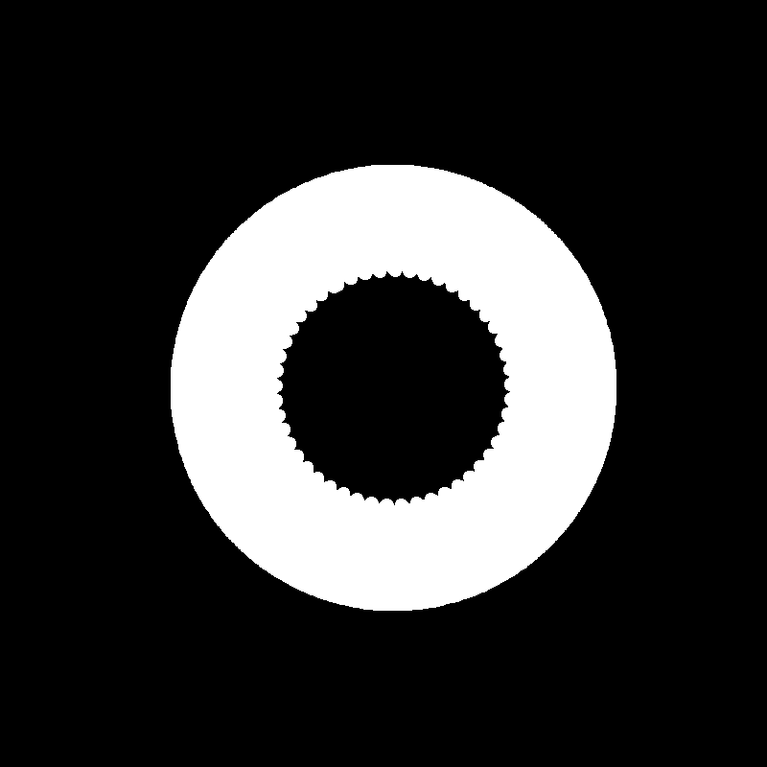

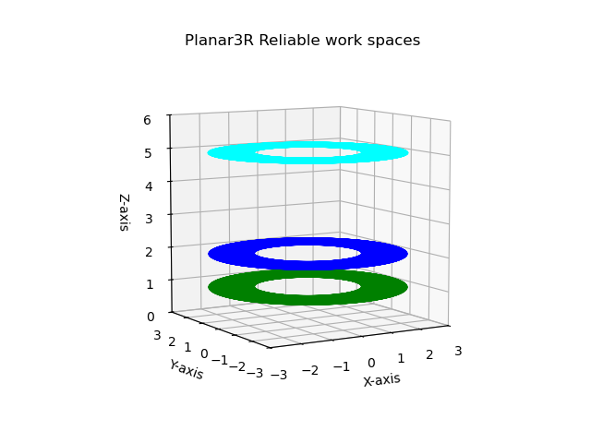

Planer 3R add plot from other papers
1 1 1 done both，done both fully optimized
0.5 1.25 1.25 done both done both fully optimized
Null space= sqrt 1/3 2^0.5, 2^0.5, (2/3)^0.5 done both fully optimized

Spatial 4R draw a cut of plane sampled

Optimal case

Null space= sqrt 1/4

Spatial 7R

Optimal case

Approximately optimal

Kinova 7R not ft, ssm

Null-space=sqrt 1/7 not exist

Spatial 4R FTW optimal configuration considering volume from paper:( A*C)
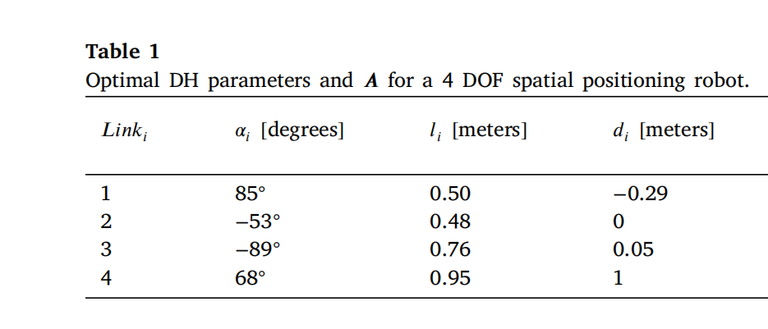
Name | Theta ranges | Volume | Connectivity | Data sampled | Kernel size | A*C
Generic algorithm optimal value | [(-0.8730382117746103, 0.8730382117746103), (-3.07870404714172, 2.979105017877223), (-2.965730966059918, 2.831650417251087), (0.6494635825661303, 2.9645940008572973)] | 14884 | 0.8763886245672803 | 72 | 1 | 13044.1682880594
512 precise examination | The same as above | 16558 | 0.5540678137593203 | 512 | 1 | 9174.254860226827
Result from paper | 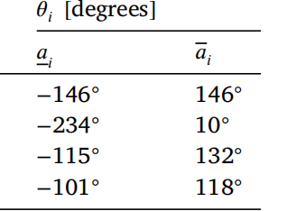 | 15408 | 0.31036089406691103 | 512 | 1 | 4782.040655782966
512 72
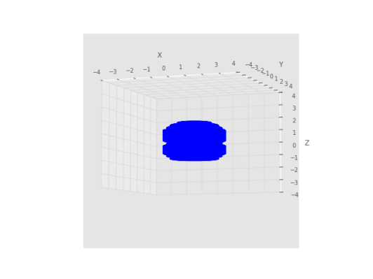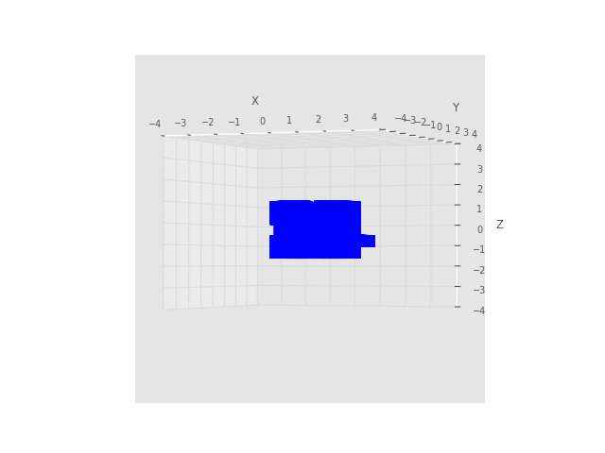
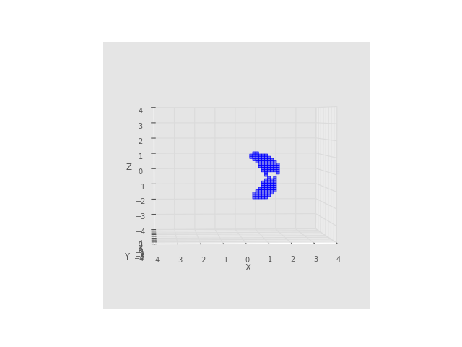
1058
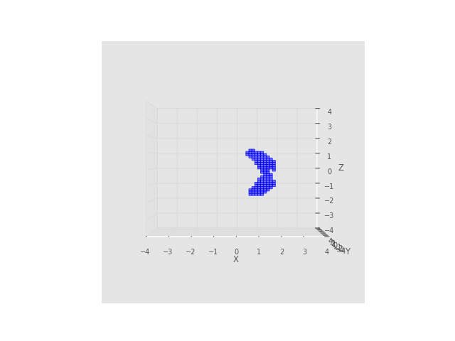
5000
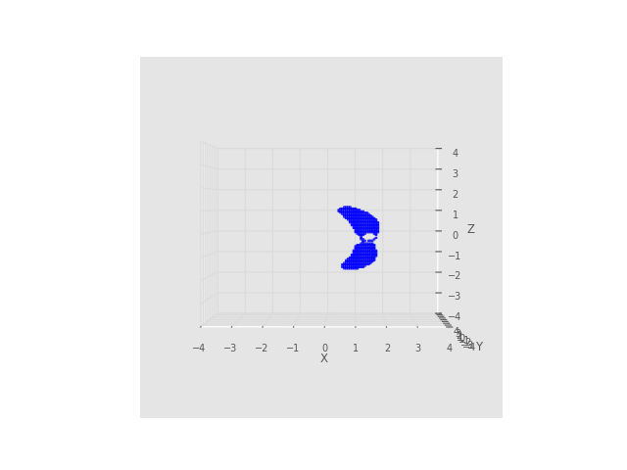
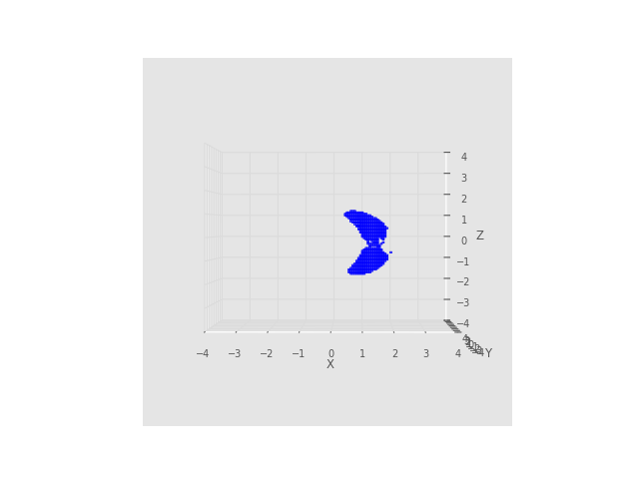

Spatial 4R reliable connectivity
Optimal alpha d a considering Volume from paper
Name | Theta ranges | Data sampled | Kernel size | Sum R*A*C | Collection
Generic algorithm optimal value | [(-0.34476583954363793, 0.34476583954363793), (-3.8557928335253506, 0.5727802075632915), (-2.0120387975312504, 0.8610682582634244), (-1.6048847508602293, 2.1951493670529656)] | 72 | 2 | 136209.76653336152 | 32968.0  21369.84189197529  20613.81172796665  16481.845114886735  18392.0  16801.69461282132  13781.4552834269  18767.938681802072  16481.845114886735  15240.0  17482.0  13781.4552834269  14375.0  15240.0  14375.0
512 precise examination | The same as above | 512 | 2 | 109008.53420367329 | 20808.398108199894  16927.251651361243  16987.79082547002  14093.13662524901  12621.292182668985  17878.412747913673  13084.29688512255  13226.114612169082  12581.488580139396  14093.13662524901  12121.206204992744  11721.450956380077  13084.29688512255  12581.488580139396  11721.450956380077
Result from paper

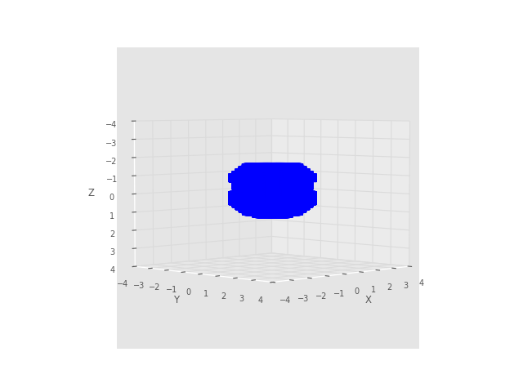
1058 points

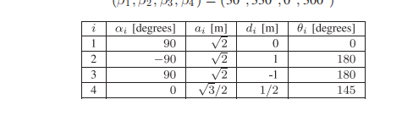
4 rows x 5 columns]
87 [1.5707963267948966, -1.5707963267948966, 1.5707963267948966, 0.0]
27 [1.5707963267948966, -1.5707963267948966, 1.5707963267948966, 0.0]
0 [1.5707963267948966, -1.5707963267948966, 1.5707963267948966, 0.0]
65 [1.5707963267948966, -1.5707963267948966, 1.5707963267948966, 0.0]
Name: alpha, dtype: object
87 [1.4142135623730951, 1.4142135623730951, 1.4142135623730951, 0.8660254037844386]
27 [1.4142135623730951, 1.4142135623730951, 1.4142135623730951, 0.8660254037844386]
0 [1.4142135623730951, 1.4142135623730951, 1.4142135623730951, 0.8660254037844386]
65 [1.4142135623730951, 1.4142135623730951, 1.4142135623730951, 0.8660254037844386]
Name: a, dtype: object
87 [0, 1, -1, 0.5]
27 [0, 1, -1, 0.5]
0 [0, 1, -1, 0.5]
65 [0, 1, -1, 0.5]
Name: d, dtype: object
87 [(-0.15798048975852233, 0.15798048975852233), (1.3847495872170423, 2.4344699871967173), (-3.013074541299022, -0.20428201822201242), (-1.2707294073172148, 2.4655786159604465)]
27 [(-0.07906649216587758, 0.07906649216587758), (-0.9732464627652484, 1.5850429260354852), (-2.897419593132771, 0.25890117069376783), (0.5296134975045463, 2.1936521996198044)]
0 [(-0.5238439325858762, 0.5238439325858762), (-2.4619119712660495, -0.2050902210235419), (-1.6002452328689767, -0.24313541696041252), (1.8867157859248653, 1.9386821615512457)]
65 [(-0.04166562492503941, 0.04166562492503941), (-4.727749881133764, -2.6403357174933215), (2.8230353383158544, 3.0533838071811643), (-0.5842100730352158, 1.5512756294372636)]
Name: theta, dtype: object
87 396.718373
27 304.000000
0 248.000000
65 200.000000
Name: connectivity, dtype: float64
Generation 0 completed,1generated.

The volume of the shape in the original image is 7808 pixels.
the connected connectivity of given shape is 0.8814773952196455
the general connectivity of given shape is 6882.575501874992

- A way to measure connectivity of orientation values

Given 3D data(x,y,z) from(0-2pi)
Create a 3D graph G with vertex{all data}
Define kernel size(kz=pi/180)
For each data i(xi,yi,zi), n=num of data size
For each data j, i!=j m=n-1
If abs(xi-xj)<=kz and abs(yi-yj)<=kz and abs(zi-zj)<=kz
Connect i with j in G
Return Undirected graph G

Num erosion= vertex connectivity of G(minimum number of vertex whose removal disconnects the graph)
Num dilation=Num_vertices_removed

Connectivity=0
Num_erosion=0
num_vertices_all=len(data)
Num_vertices_removed=0
Num_component=num_c(G)
While Num_component+Num_vertices_removed!=num _vertices_all:
Smallest kmin=99999
Vertices_to_remove=[]
For component Ci
If |Ci|>=2: compute Min vertex cut of Ci: kmin
If kmin<smallest kmin: smallest kmin=kmin
Vertices_to_remove=[a,b,c....]
If Smallest kmin==99999: break
Remove Vertices_to_remove from G-> G’
Connectivity+=e^(-0.5*Num_vertices_removed)*(Smallest kmin-1)
Num_vertices_removed+=Smallest kmin
Connectivity+=e^(-0.5*Num_vertices_removed)

Connectivity/=Num_vertices_removed
General connectivity=num of edges*Connectivity

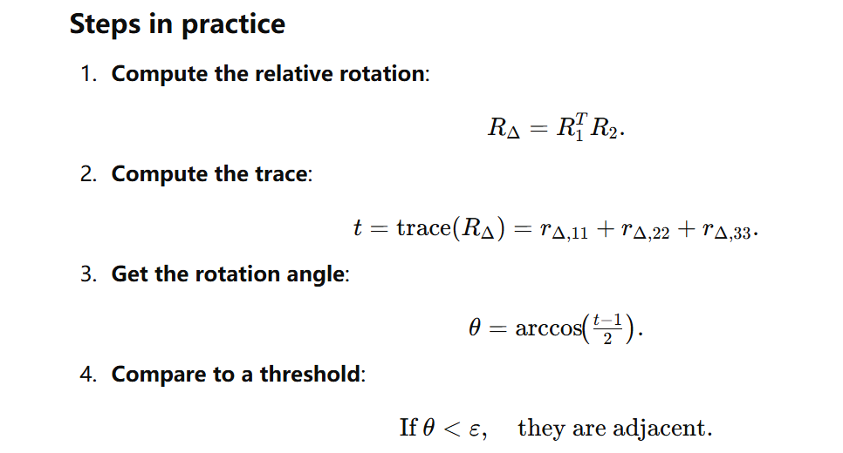

- Hypothesis of computing orientation ftw
Row pitch yaw representation
Yaw: rotate about z0 axis

Similarly, we sample orientations from a unit sphere with yaw angle=0,row and pitch angle in 0 to 2pi,then rotate this unit sphere by yaw angle is just phi +x degrees, we maybe can compute fault tolerant orientation space by using the same ssm algorithm?
Then the result will be for each(row,pitch) point on that unit sphere, we have beta-ranges represents fault tolerant ranges of yaw angles

ring torus
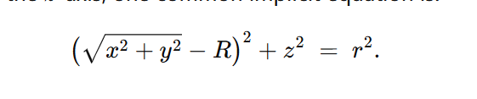
A valid way to represent 2 angles(range from 0 to 2pi)?
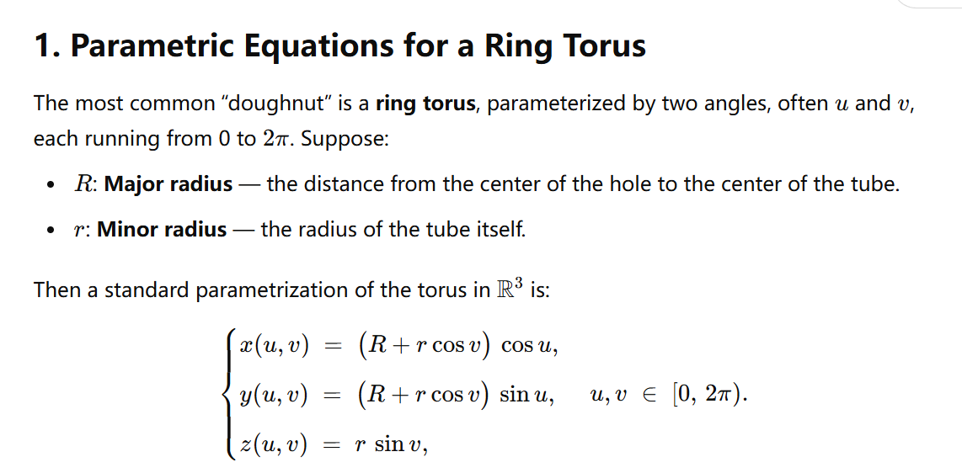

Implement algorithms for 7R
Run more points for 4R results of GA

50 25
The volume of the shape in the original image is 9452 pixels.
the connected connectivity of given shape is 1.0
the general connectivity of given shape is 9452.0
average orientation connectivity over 25 is 789.0488805373504
positional connectivity:9452.0
Function 'ssm_estimation' took 2059.3453 seconds

72 36
The volume of the shape in the original image is 10768 pixels.
the connected connectivity of given shape is 1.0
the general connectivity of given shape is 10768.0
average orientation connectivity over 36 is 819.8798311207997
positional connectivity:10768.0
Function 'ssm_estimation' took 11471.3559 seconds

108 25
The volume of the shape in the original image is 10592 pixels.
the connected connectivity of given shape is 1.0
the general connectivity of given shape is 10592.0
average orientation connectivity over 25 is 2781.7044410902176
positional connectivity:10592.0
Function 'ssm_estimation' took 7746.0712 seconds

72 64
The volume of the shape in the original image is 11988 pixels.
the connected connectivity of given shape is 1.0
the general connectivity of given shape is 11988.0
sampled 72 points with 10 positional fault tolerant
average orientation connectivity over 64 is 577.1775655177782
positional connectivity:11988.0
Function 'ssm_estimation' took 8582.0106 seconds
C1
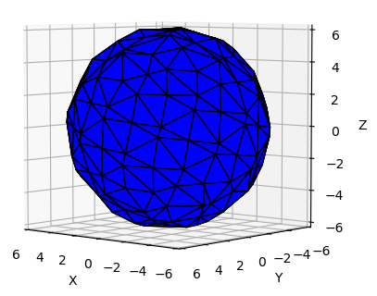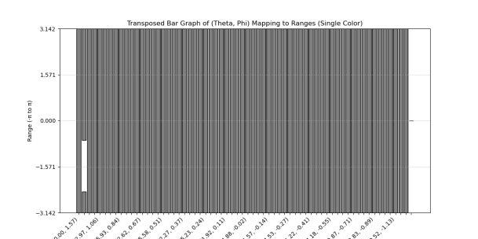

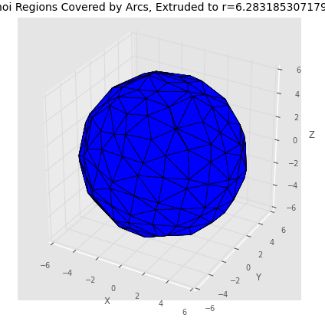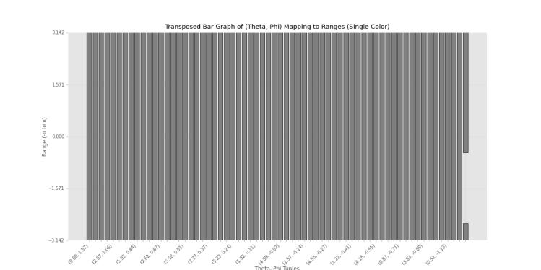

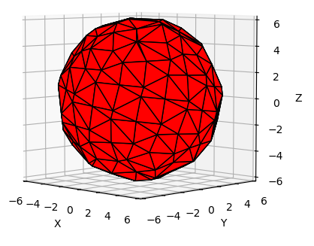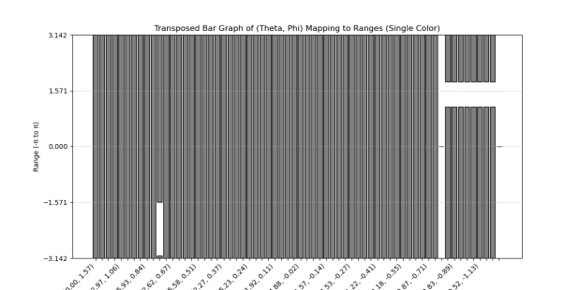

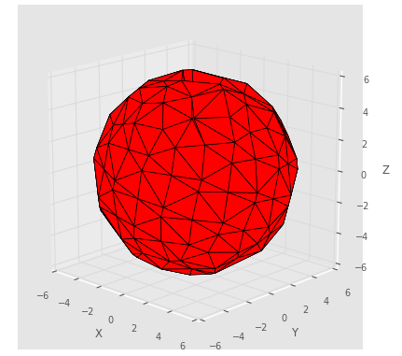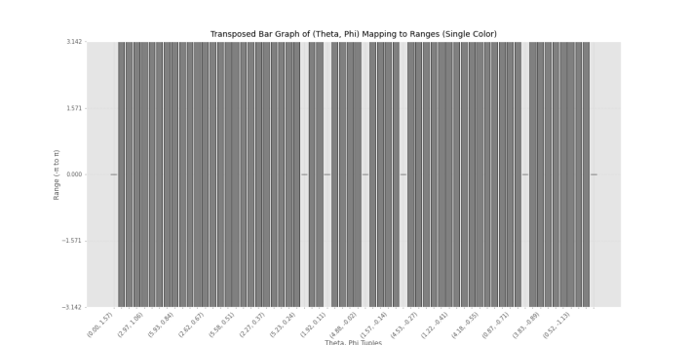
C1

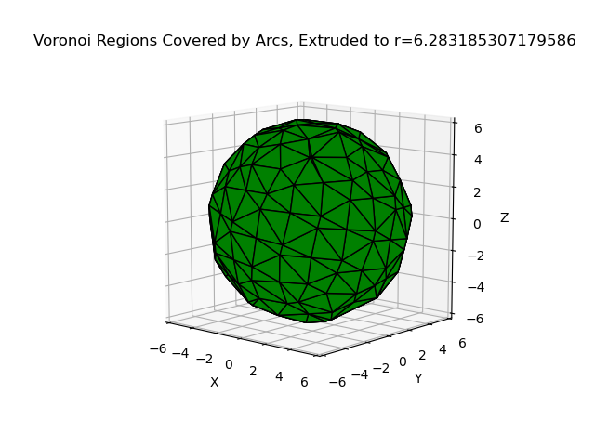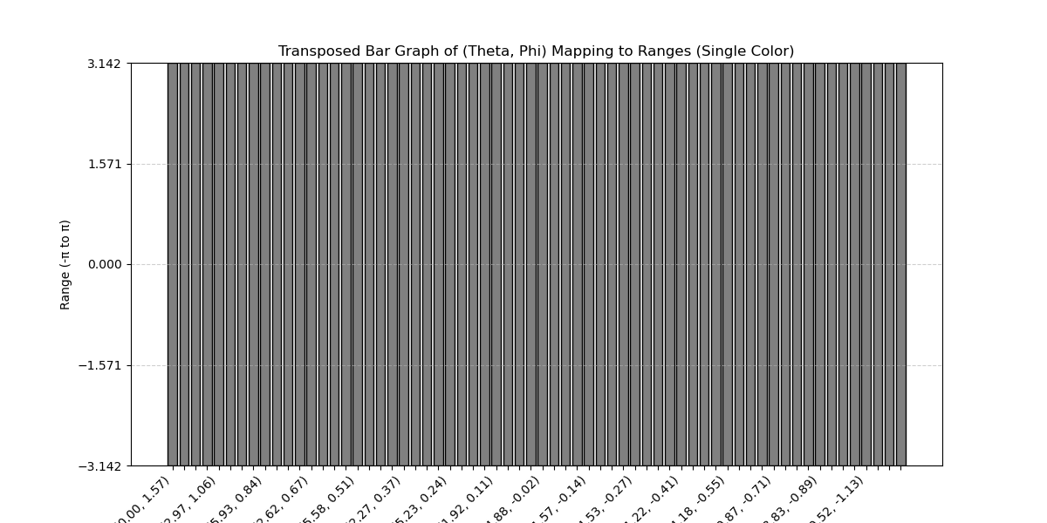
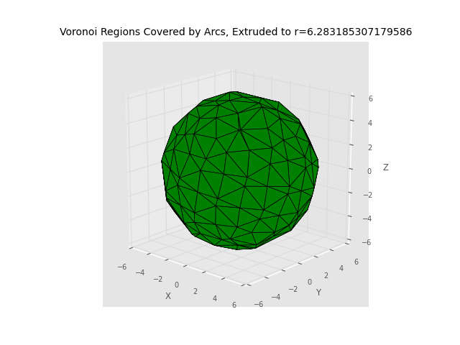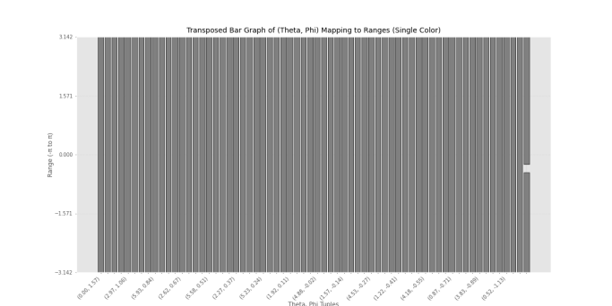

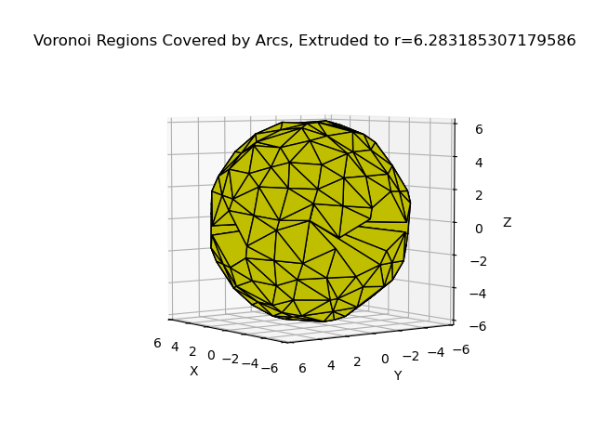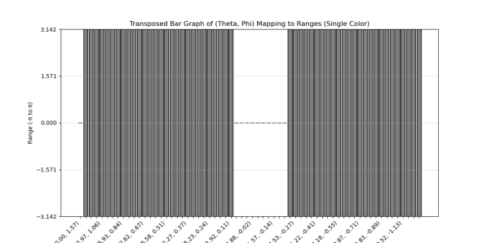
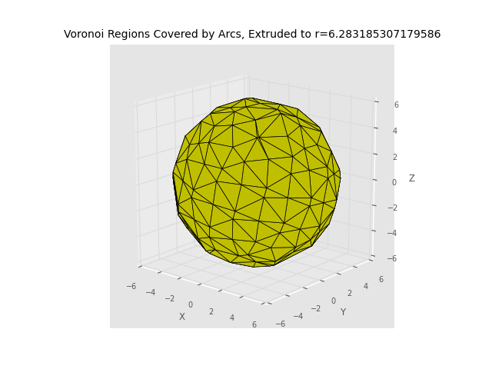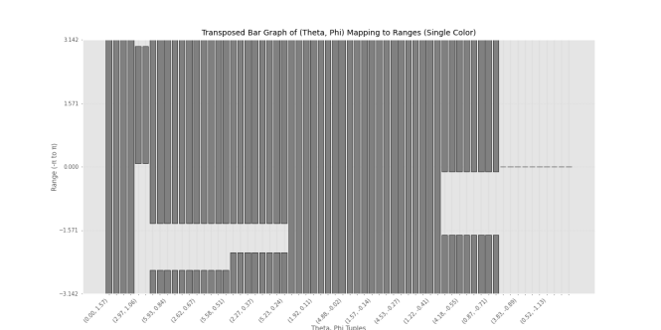

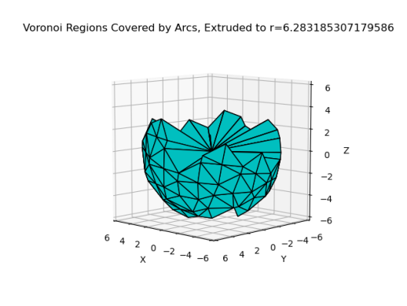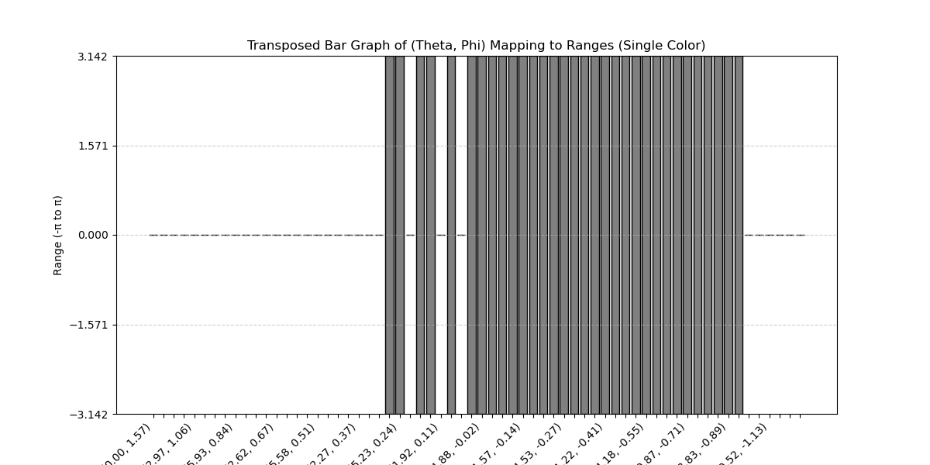
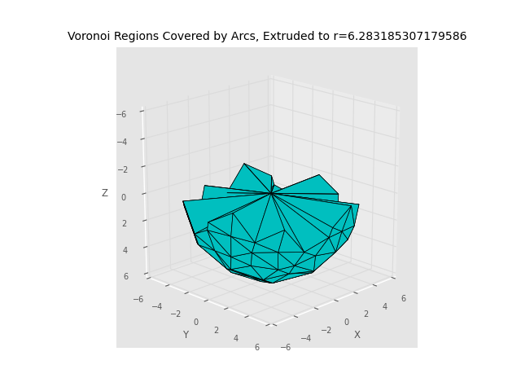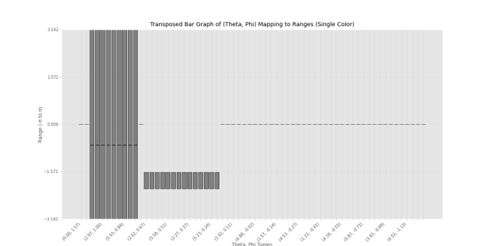
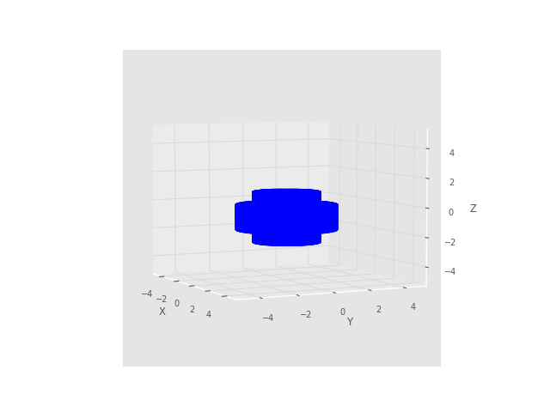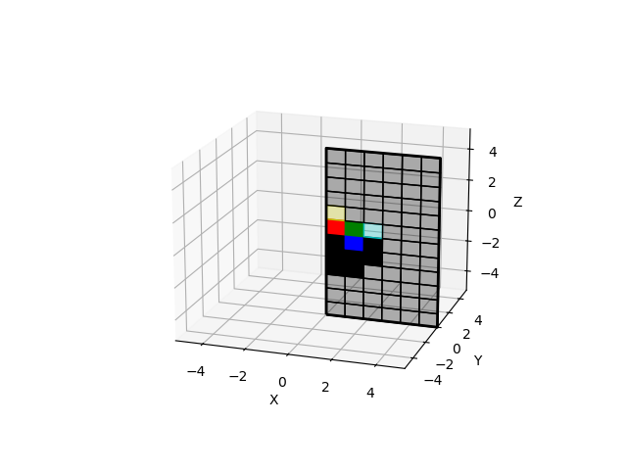
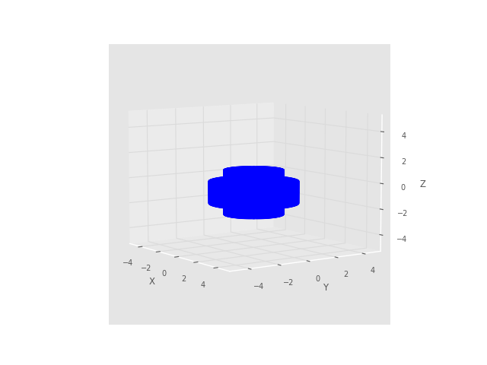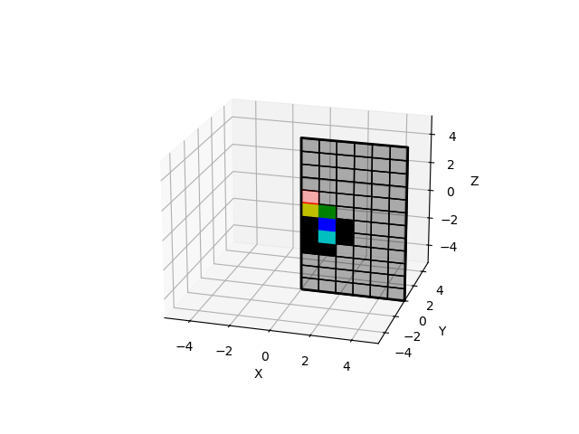

C1：
The volume of the shape in the original image is 11988 pixels.
the connected connectivity of given shape is 1.0
the general connectivity of given shape is 11988.0
sampled 72 points with 10 positional fault tolerant
average orientation connectivity over 64 is 577.1775655177782
positional connectivity:11988.0
Function 'ssm_estimation' took 16582.1450 seconds

C2(lw+10, up-10)
The volume of the shape in the original image is 11988 pixels.
the connected connectivity of given shape is 1.0
the general connectivity of given shape is 11988.0
sampled 72 points with 10 positional fault tolerant
average orientation connectivity over 64 is 657.8134114082434
positional connectivity:11988.0
Function 'ssm_estimation' took 22332.8579 seconds

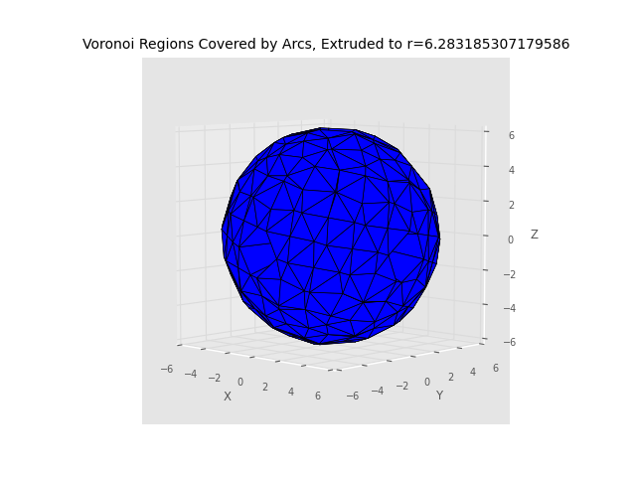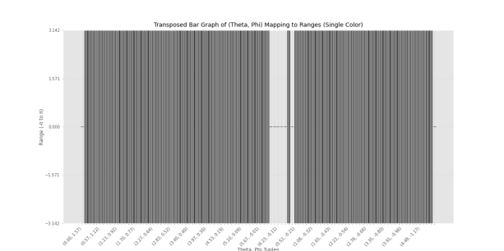

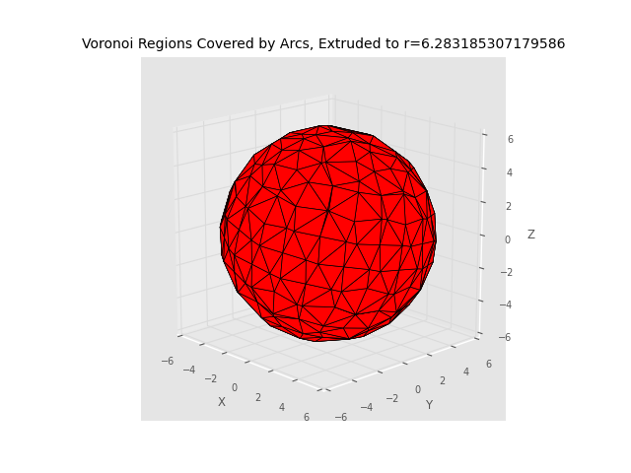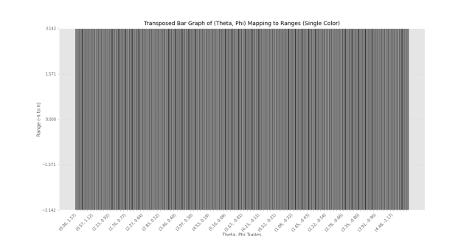
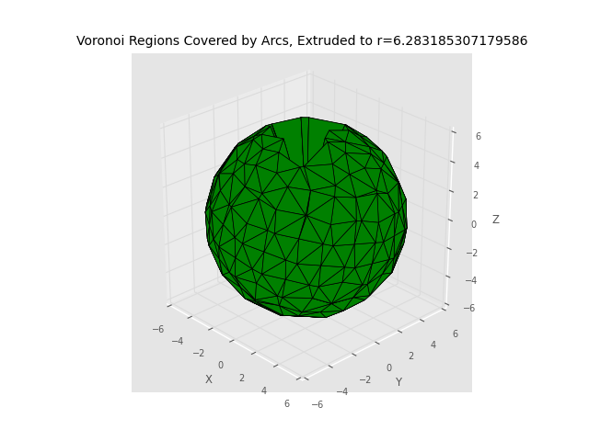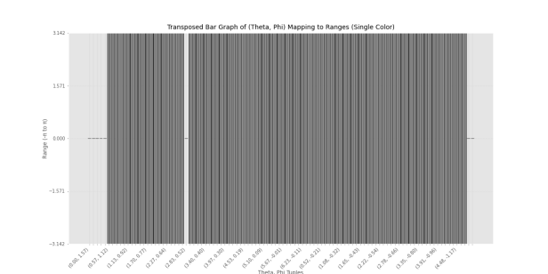
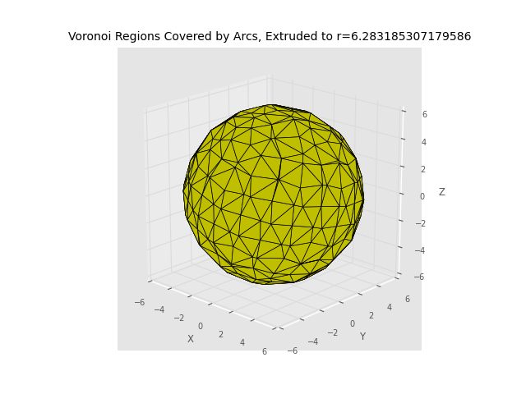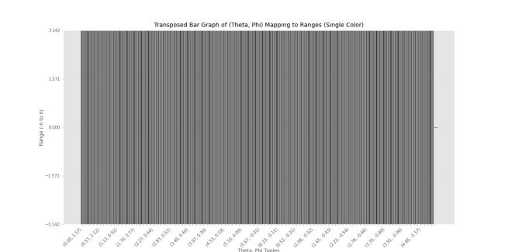
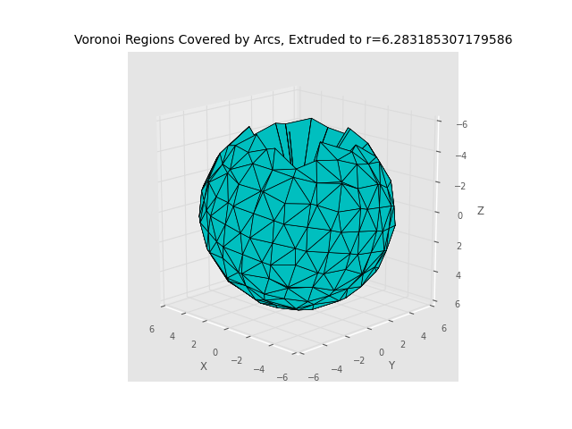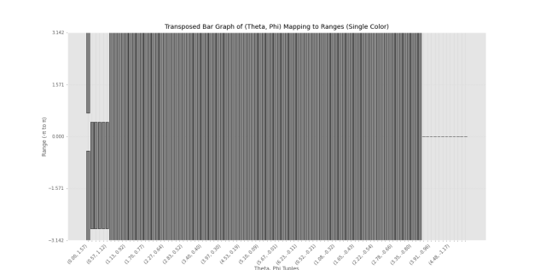
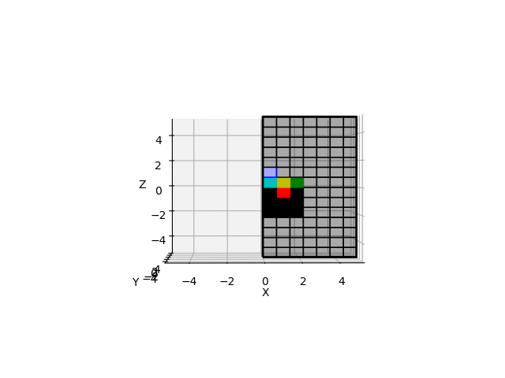
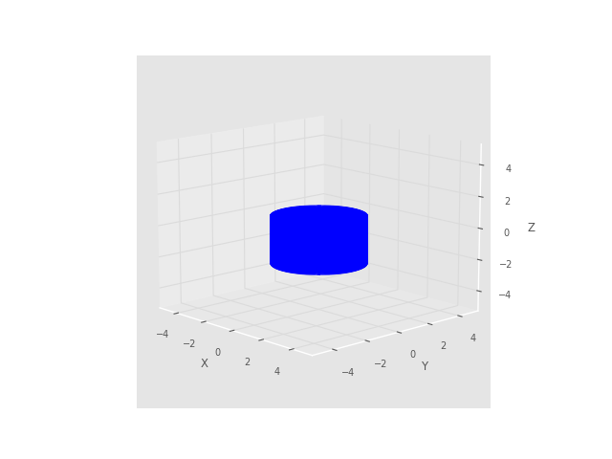

The volume of the shape in the original image is 10080 pixels.
the connected connectivity of given shape is 1.0
the general connectivity of given shape is 10080.0
sampled 98 points with 12 positional fault tolerant
average orientation connectivity over 100 is 560.050450111398
positional connectivity:10080.0
Function 'ssm_estimation' took 17819.1868 seconds

C1：
The volume of the shape in the original image is 11988 pixels.
the connected connectivity of given shape is 1.0
the general connectivity of given shape is 11988.0
sampled 72 points with 10 positional fault tolerant
average orientation connectivity over 64 is 577.1775655177782
positional connectivity:11988.0
Function 'ssm_estimation' took 16582.1450 seconds

C2(lw+10, up-10)
The volume of the shape in the original image is 11988 pixels.
the connected connectivity of given shape is 1.0
the general connectivity of given shape is 11988.0
sampled 72 points with 10 positional fault tolerant
average orientation connectivity over 64 is 657.8134114082434
positional connectivity:11988.0
Function 'ssm_estimation' took 22332.8579 seconds

3R spectrum repre, 4R transparent spectrum repre , reliability map ,4r 7r try more samples
7R transparent spectrum repre ,orientation only surface of unit sphere, make it transparnent, use color based on length of alpha ranges

Create outline on overleaf

